SERVICENOW WEEK-3

**What is ServiceNow?**

ServiceNow is a **cloud based platform,**which was mainly developed for workflow and process automation as per the ITIL principles.

ServiceNow is also hosted on the cloud means You can say that hypothetical storage where you will find data if you define security where you’ll find storage devices and all are hypothetical it’s just a hypothetical where the stores are on the cloud and you can access it from anywhere so to make it access **freely available** from anywhere.

It provides **Application Platform as Service** same as cloud .

Service or application platform as a service where you will have to create your own application on that particular platform and that platform will **automatically host your application** on the cloud and **without writing a single line of code** you would be able to develop your **desired application,desired workflow** and you can do entire **customization** on the ServiceNow instance so that’s why all the organizations are moving towards ServiceNow because **no code** **environment** is there so everything is moved to ServiceNow.

However,it is highly customisable and also can be used for other purposes.

**Services Of ServiceNow**

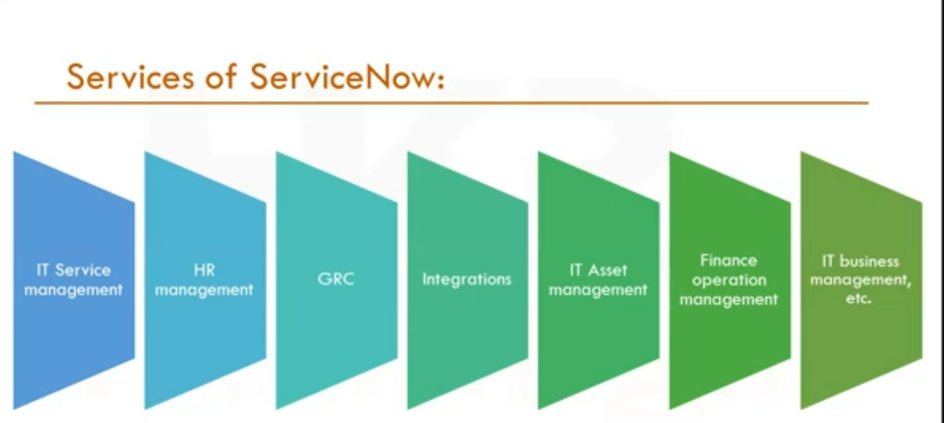

**Basic Service provided by ServiceNow ITSM**

**IT Service Management (ITSM):**

* Incident Management: Track, manage, and resolve IT incidents.
* Problem Management: Identify the root cause of incidents and prevent recurring issues.
* Change Management: Ensure controlled changes in IT environments.
* Request Management: Manage service requests from employees or customers.

**HR Management(Human Resource Management)**

* Whereever you are being part of any organization there is a mail from your HR or from the team who are handling servicenow are called HR management.
* Mostly Deals with **onboarding and off-boarding** of resources .
* They will take care of all the activities all the functions all the stuff taken care by the HR so these are the modules which are available in each of the organization.

**GRC(Government,Risk and Compliance)**

* It’s not a part of all organization but most of the organization which are from **banking** **sectors** GRC and the finance opening system they are using this module because of the **security feature**.
* It’s called government risk and compliances-so here it will analyze the risk involved in the development and they will go and check compliances issues during this particular phase
* **Financial Management** also belong to Banking Sector.

**Integration**

* Integration is the place where you **will connect two system together** .
* Like we are on servicenow instance and if we want to get data from other system example banking domain only I want to get the data from the banking broker in this case ITSM integration will help to get the details from the third party this is called integration.

**IT Asset Management**

Every organization there are assets which are need to be managed by most of the organization like to whom this laptop has been assigned to whom this data card has been aasigned all the serial number all that will be taken by this IT Asset Management.

**IT Business Management**

It deal with the business point of view what your business is doing so basically these are most important services and the base will be your ITSM then on that page other modules are beimg built.

**How to Get Free SNOW Instances?**

Particular Website call developer.servicenow.com and this is a place where you will register.Singnup and start building page will appear

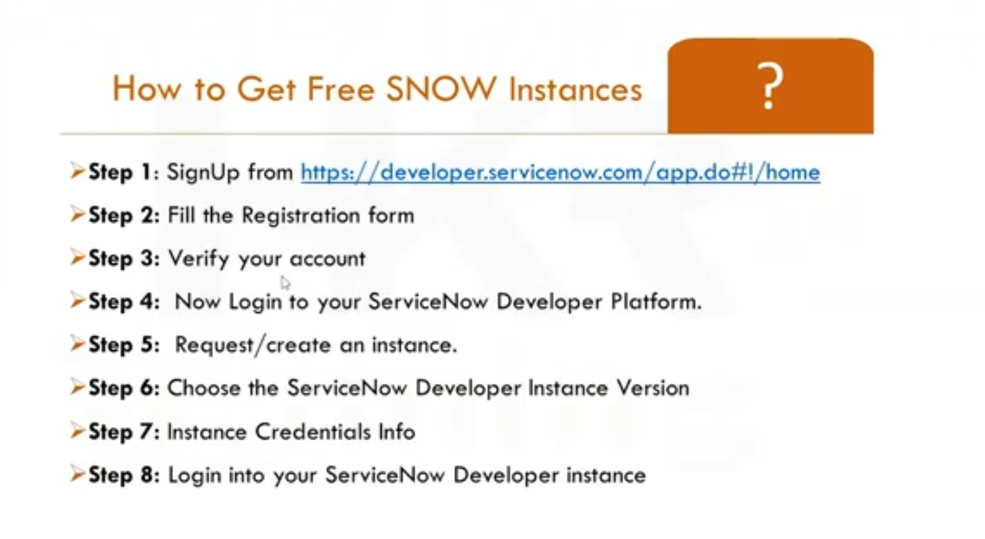

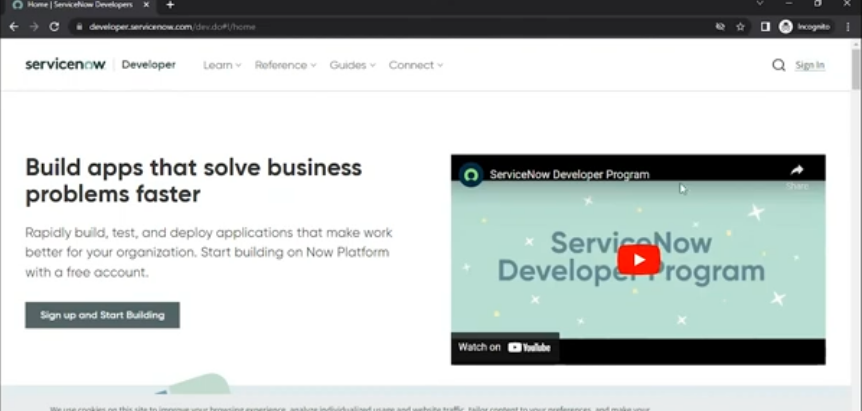

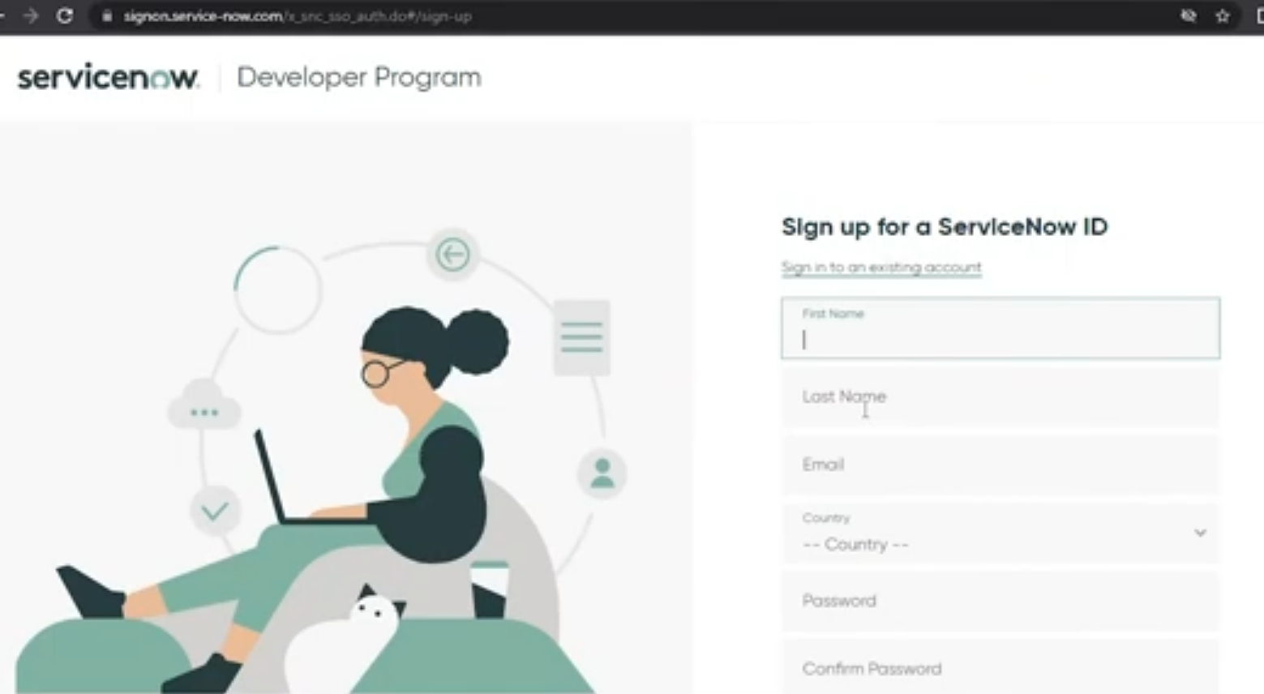

**Instance Activity**

If the instance is **inactive** for **10 days**,then the instance is released

If your instance is inactive for more than **24hours**,then your instance may go into **hibernation state**.

**How to become a SNOW Developer?**

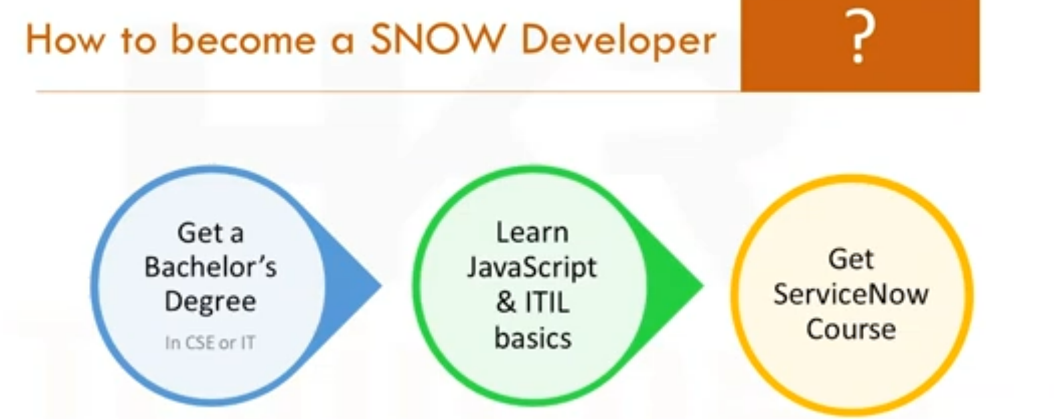

**Career and growth in ServiceNow**

* ServiceNow is expected to continue to grow even in future.
* Currently,Cloud Platform is the Very popular.
* In the cloud platform,ServiceNow is the best tool to use because of its simplicity and ease of use.

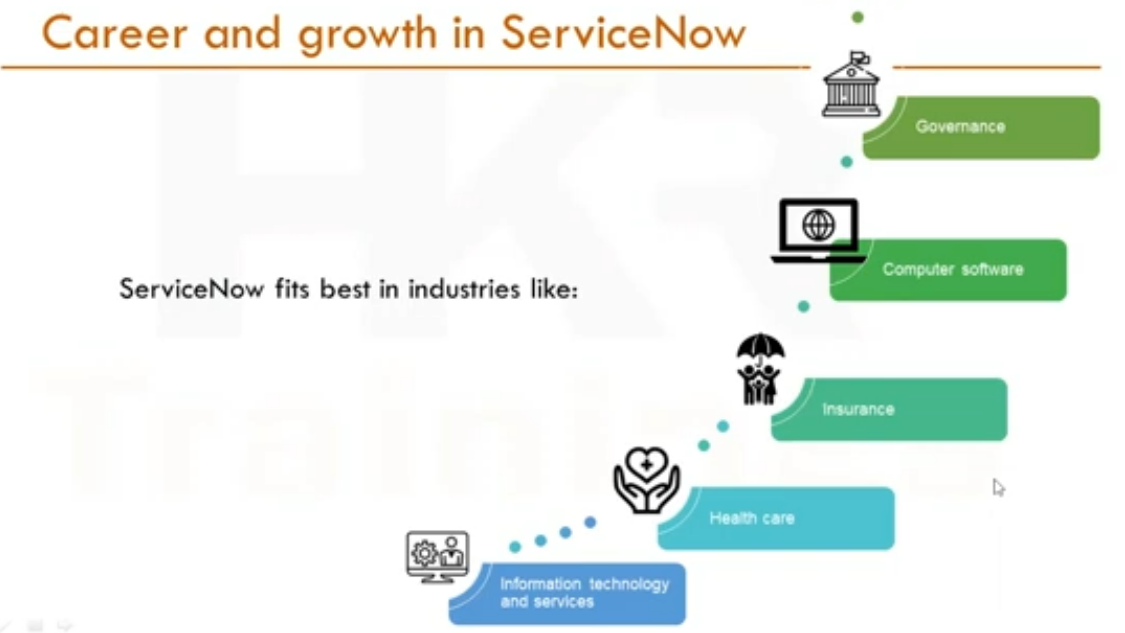

**ServiceNow Certification Training**

* **Certified System Administrator** (CSA): Entry-level certification for managing the platform.
* **Certified Application Developer** (CAD): For custom application development.
* **Certified Implementation Specialist** (CIS): Specialized certifications in areas like ITSM, ITOM, HR, and SecOps.
* **Certified Technical Architect** (CTA): Advanced certification for designing complex implementations. These certifications are highly recognized in the industry and enhance job prospects and salary potential.

**ServiceNow User Interface Overview**

* We interact with the application and modules of the ServiceNow Platform through the user interface using a web browser.
* The version of the user interface that accompanies the Istanbul Version of Servicenow is called UI16

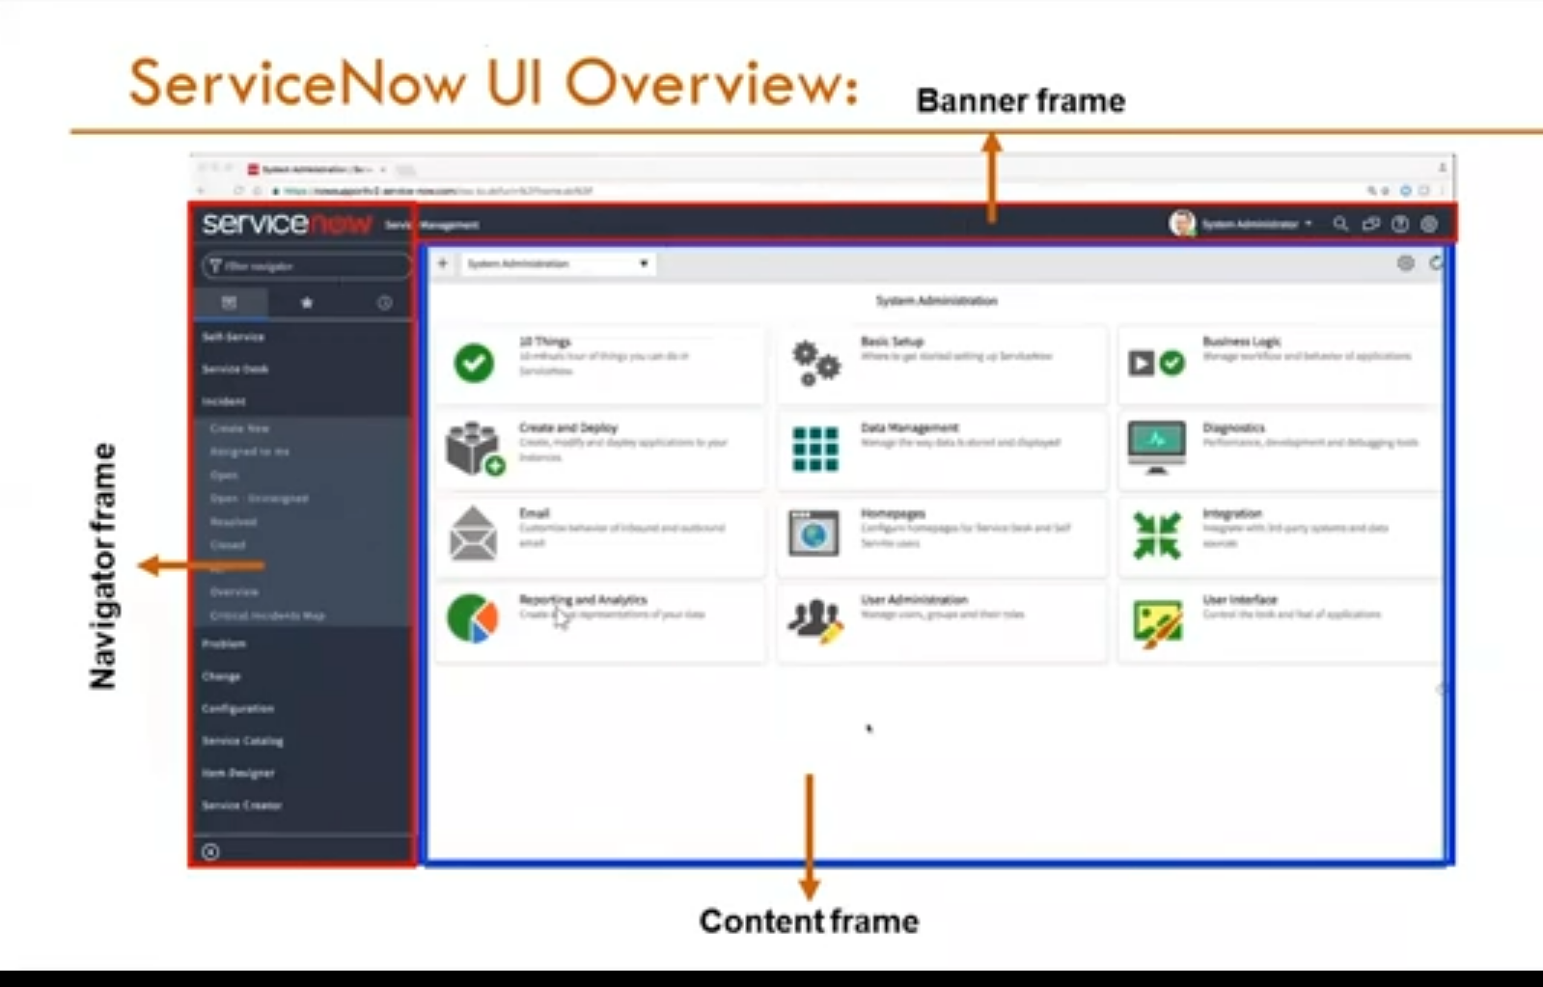

**3** Main Screen Elements

1.**Banner Frame**-**Logo**;**UserMenu**(profile,Impersonate User(Access to admin or impersonate user),Elevate Roles,Logout);Tools(**Globalsearch**-record matching keyword,**conectchat**-realtime messaging,**help**-contextual help,access to user guide and documentation search);**System Settings**(Customize the UI to their preferences)General,**Theme,Accessibility,List,Forms,Notifications,Developer** **settings**.

2.**Application Navigator-**Navigation Filter,All Applications,History(30 items),Favorites.

3.**Content Frame**

The Content Frame is the main area in the ServiceNow interface where the content related to the selected application or module is displayed. This is where users interact with forms, lists, dashboards, reports, and other data.

**Modules in ServiceNow**

Modules are the elements that make up the Servicenow application navigator . Module: Represents a specific function or task within an application menu, such as viewing a list of records, creating new records, or accessing a report.

All - system definition - application menus - module

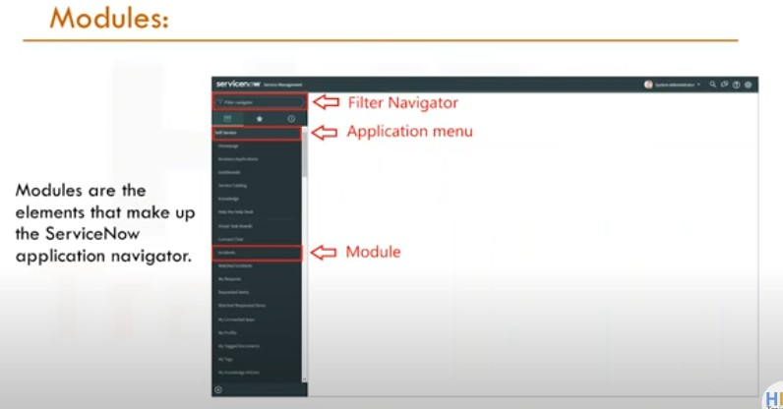 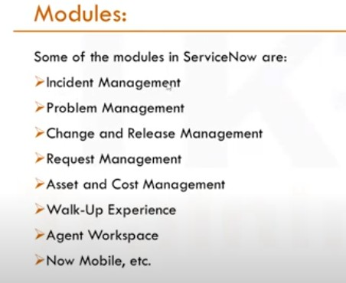

**Application Menu**

Application Menu is a navigational element that organizes and groups related modules (functionalities) within the platform, making it easier for users to find and access the tools and features they need to perform their tasks.

* Application Menu: Organizes related modules under a common heading, providing a structured and intuitive interface.
* Module: Represents a specific function or task within an application menu, such as viewing a list of records, creating new records, or accessing a report.

**Visualizing the Relationship:**

* Application Menu: Imagine it as a folder on your computer.
* Modules: These are the files inside the folder, each representing a specific function.
* List: When you open a file (module) that shows data, like an Excel spreadsheet, the content you see (rows and columns) is similar to a list in ServiceNow.

**Example Scenario:**

* Application Menu: "Incident"
* Module: "Open"
  + - When you click on this module, you see a list of all open incidents.
* Module: "Assigned to Me"
  + - Clicking here shows a list of incidents specifically assigned to you.

**Incident Module**

The **Incident module** in ServiceNow is designed to handle unplanned interruptions and restore normal service operations as quickly as possible. It manages incidents from logging and categorization to prioritization and assignment to the correct support teams.

The goal is to minimize impact on business operations by tracking incidents through to resolution and closure, ensuring adherence to Service Level Agreements (SLAs).

Incident management focuses on quick resolutions, allowing organizations to maintain smooth operations even when disruptions occur.

**Application Navigator** > **Incidents** > **All Incidents or My Incidents**.

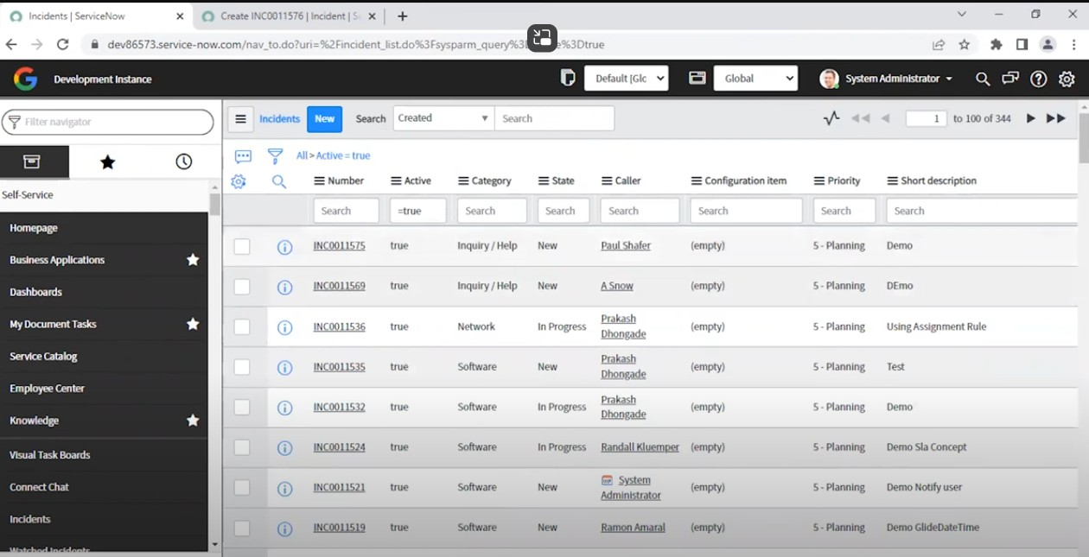

**Incident Lifecycle**:

1. **Logging**: Incident details are recorded.
2. **Categorization**: Incidents are categorized (e.g., hardware, software).
3. **Prioritization**: Based on urgency and impact.
4. **Assignment**: Sent to the appropriate support group.
5. **Resolution and Closure**: Issue is fixed, and the incident is closed.

**Problem Management**

The **Problem module** addresses the underlying causes of recurring incidents. By conducting root cause analysis (RCA), it aims to identify and eliminate the root causes of issues, preventing incidents from happening again.

Problems can be detected either reactively through incident patterns or proactively through trend analysis. Once identified, workarounds may be applied as temporary fixes while a long-term resolution is developed.

The module ensures that recurring problems are systematically handled to improve the overall stability of the IT environment.

**Application Navigator** > **Problems > All Problems or Open Problems**.

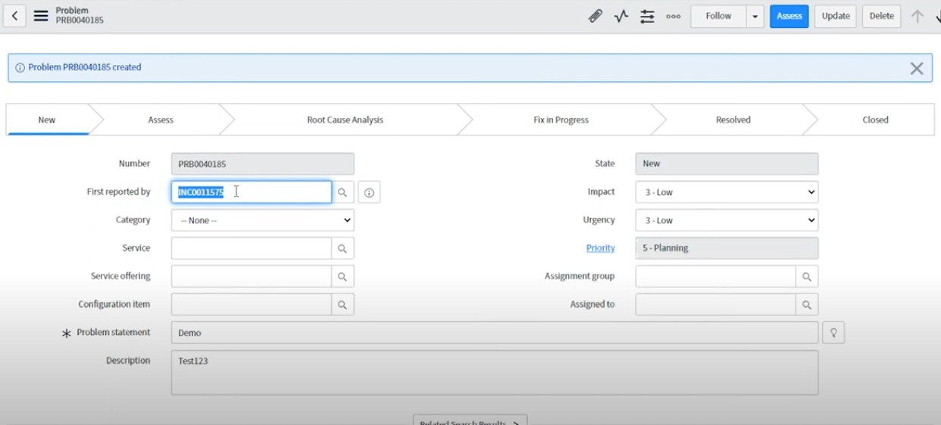

**Change Lifecycle**:

1. **Request**: A change is requested.
2. **Assessment and Approval**: The change is evaluated and approved.
3. **Implementation**: Change is made following the plan.
4. **Review and Closure**: Post-change review and closure of the request.

**Change Management**

The **Change module** facilitates the process of making controlled changes to IT infrastructure, services, or processes. This module ensures that changes are planned, assessed, and implemented with minimal disruption to business operations.

Different types of changes, such as standard, normal, and emergency, are managed through approval workflows to assess their risk and impact. Standard changes are pre-approved and low-risk, while normal changes require planning and approval.

Emergency changes are fast-tracked to address critical issues. After implementation, changes undergo a post-implementation review to ensure success and avoid new problems.

**Application Navigator** > **Changes > My Changes** or **All Changes**

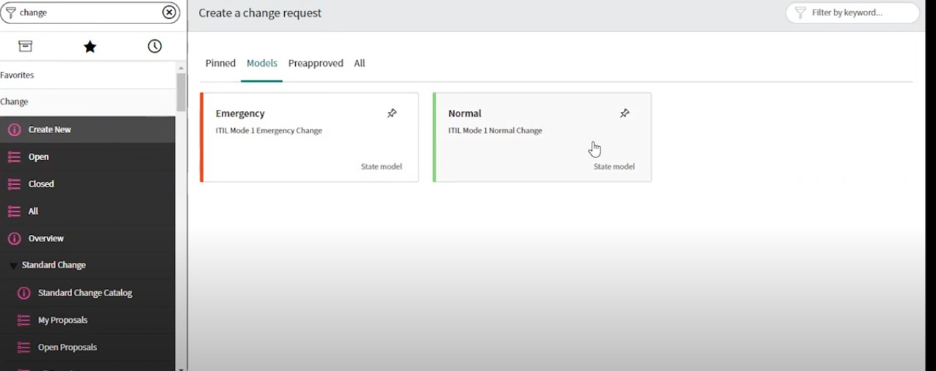

**Change Lifecycle**:

1. **Request**: A change is requested.
2. **Assessment and Approval**: The change is evaluated and approved.
3. **Implementation**: Change is made following the plan.
4. **Review and Closure**: Post-change review and closure of the request.

**ServiceNow Lists and Filters**

Lists in serviceNow are a type of interface that displays a set of records from a table in a grid or tabular format. Lists provide a way to view, filter, sort and interact with multiple records at once.

Table_name.list is used to display the list view of a table. Table_name.LIST opens list in new tab The List Header contain many useful things to perform action on list

1. List Controls
2. Filter Lists
3. Table Search bar
4. Personalize Icon

**List Controls**

In ServiceNow, **context menus in lists** provide users with quick access to actions that can be performed on list items (records) or the list itself.

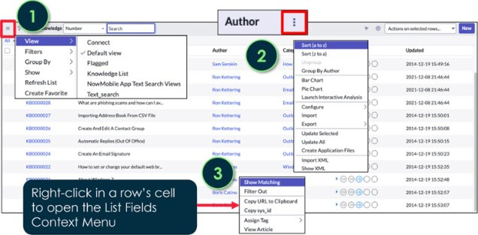

For lists there are three types

* List Control menu - Has Views, Filters, GroupBy, Refresh List, Create Favorite
* Column option men - Has Configure, import, Reporting, Sorting
* List field menu - used to copy sys_id

**Views**

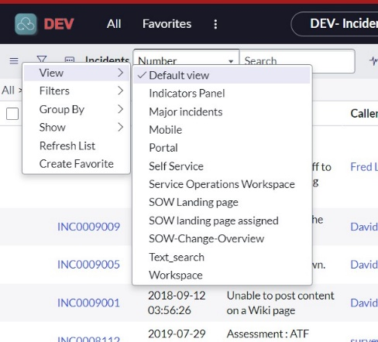Views enable users to quickly display the same list or form in multiple ways. System administrators can create views for lists or forms.

You can create view by selecting

Control options menu - configure - List Layout - select the fields using list Collector - Scroll Down to select view - new - enter the view name - save

You can see the created view from List Control Menu - views

**Filters in List**

A filter is a set of conditions applied to a table list to isolate a subset of the data. The three parts of a filter condition are:

1. Field: A choice list based on the table and user access rights. The choice list includes fields on related tables by dot-walking.
2. Operator: A choice list based on the field type.
3. Value: A text entry field or a choice list, depending on the field type.

Wildcard conditions Used in column search row

* *value contains
* !*value does not contain
* =value equals
* !value does not equal Value % starts with
* % value ends with

Add filters to your Favorites by clicking the List Controls icon and selecting Create Favorite

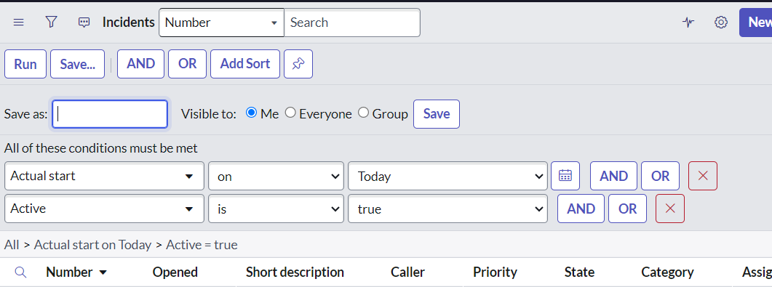

In the classic list, select **Run** to see the results of your filter displayed in the list.

To save a filter, select **Save.** A new field will appear where you can name your filter. After naming the filter, select who it will be visible to, then select the Save button to the right of the name and visible to options.

The new filter will be available by selecting Filters from the list context menu.

**Breadcrumbs**

Filter conditions applied to the list are summarized in the breadcrumbs, shown in blue letters across the top of the list. Not only do the breadcrumbs provide an “at-a-glance” view of the filter’s conditions, but they allow you to modify conditions as necessary.For example, you can select the greater than sign before a condition to remove that condition, or select a breadcrumb to remove all of the conditions that follow.

**List Personalization**



* Personalize List modifies the layout of a list for an individual user. It does not affect the platform default.
* Personalization should be used for temporary situations. Global changes will not be reflected in a personalized list

If the system administrator configures a list view a user has personalized, they will not see those newly added default changes until they choose Reset to Column Defaults.

**ServiceNow Workflows**

A workflow is a set of activities or tasks that automate a business process. Workflows help streamline processes, enforce business rules, and reduce the need for manual intervention.

**4 Primary Workflows of ServiceNow IT Workflow**

Focuses on automating IT service management processes.Includes Incident , Change and Request Management.

Example: Resolving an IT incident or processing a change request.

**Employee Workflow**

Streamlines internal processes to enhance the employee experience.Includes HR Service Delivery, Employee Center, and Employee Onboarding.

Example: Automating new employee onboarding or handling HR requests.

**Customer Workflow**

Enhances customer service and support functions.Includes Case Management, Field Service Management, and Customer Service Management.

Example: Managing customer inquiries or scheduling a field service appointment.

**Creator Workflow**

Allows custom app development to meet unique business needs.Includes App Engine, Integration Hub.

Example: Building a custom application to automate a specific business process.

**Workflow and Process Automation as per ITIL Principles:**

* **ITIL Alignment**: ServiceNow aligns with ITIL standards for IT service management.
* **Automation Benefits**: Automates workflows in IT, security, HR, and customer service.
* **Efficiency**: Reduces manual efforts, improves service delivery, and ensures consistency across processes.

**Service Delivery Areas**

**IT**: Manages incidents, changes, problems, and requests for IT services.

**Security**: Handles security incidents and vulnerability management.

**HR Service Delivery**: Automates onboarding, case management, and employee inquiries.

**Customer Service**: Manages customer cases and integrates with other departments for a seamless experience.

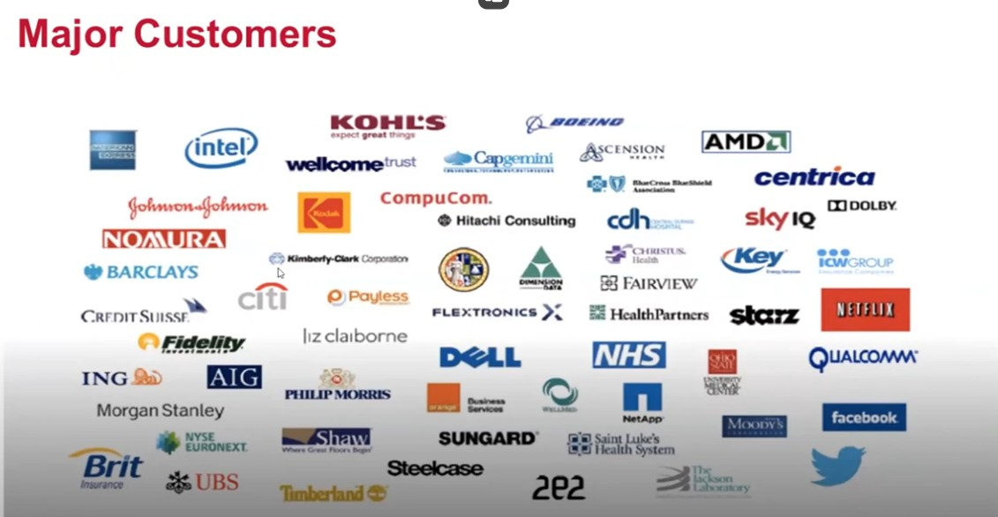**Business Applications**: Custom applications built on the ServiceNow platform to automate business-specific workflows.

**Industries**: IT, healthcare, finance, government, and retail.

**Global Customers**: ServiceNow is used by major enterprises worldwide to manage and automate IT and business processes.

**Notable Customers**: Coca-Cola, Deloitte, Accenture, and Unilever

**ServiceNow Architecture**

The ServiceNow Platform is an Application Platform-as-a-Service. This means the platform resides in the cloud. Companies no longer have to buy and manage the equipment necessary to host these applications.

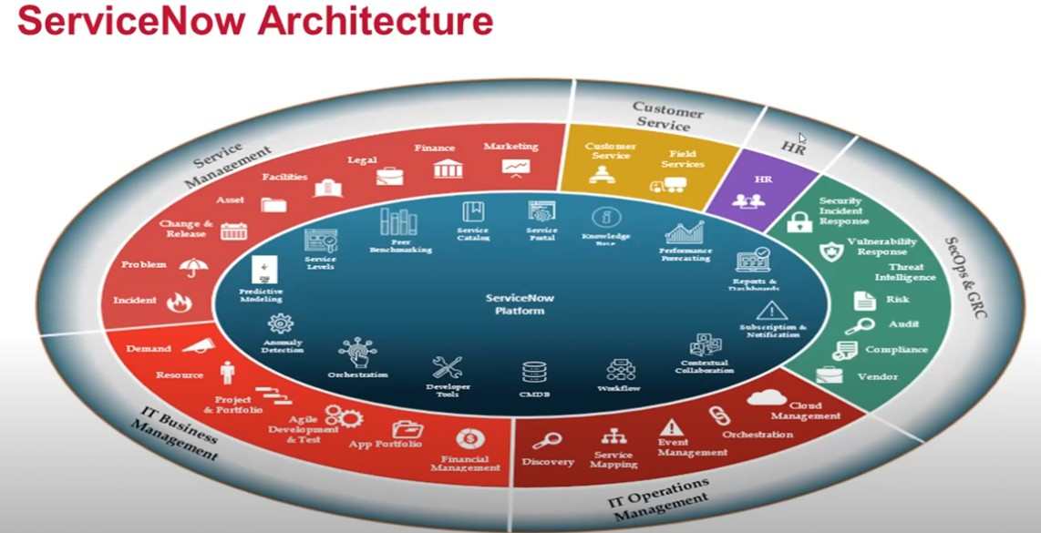

* ServiceNow utilizes an advanced, multi-instance, single-tenant architecture as the default offering for customers, meaning an instance features an individually isolated database containing data, applications, and customizations.
* ServiceNow provides services to its users from a configurable web-based user interface, built on top of a flexible database schema.
* The Platform and the applications that run on it use a single system of record to consolidate an organization's business processes.
* The Platform integrates with other enterprise systems and supports a wide variety of plug-and-play applications.

**DashBoards in Servicenow**

A dashboard is a custom arrangement of widgets and enables you to display multiple performance analytics and reporting on a single screen.

Navigate to **Self Service > Dashboards** to view the different dashboards in your instance.

Dashboards enable us to display multiple Performance Analytics, reporting, and other widgets on a single screen. Use dashboards to create a story with data that can be shared. Dashboards can be responsive or unresponsive. Responsive dashboard functionality is enabled by default. Non-responsive dashboards have limitations including who can create, view, and edit them.

Advantages

* Share Performance Analytics and Reporting visualizations on both Workspaces and classic dashboards
* Create and edit Performance Analytics reports and other widgets directly from the dashboard
* Use Add Widgets pane to quickly find and preview widgets, then add them to the dashboard
* Easily share dashboards with other users from the integrated sharing pane
* Use quick layouts to snap widgets into a predefined layout, then adjust the layout as desired
* Set dashboards as your homepage so you can quickly access information that you use frequently

Navigate to All > Self-Service > Dashboards to view dashboards in the ServiceNow Platform. View recent dashboards, dashboards owned by you, shared with you, or all available dashboards in your instance.

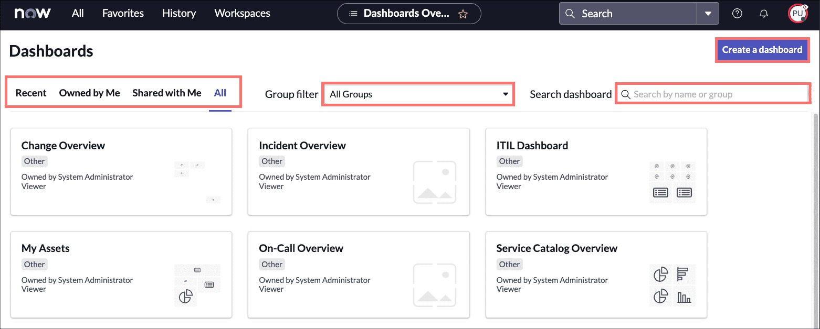

**Service Catalog in ServiceNow**

The Service Catalog application in the Platform allows users to view, request, and shop around for services and products.

* Browse around the Service Catalog interface
* Practice ordering and filling carts with catalog items
* Explore lists for Requests, Requested Items, and Tasks

The Service Catalog in your instance allows us to request IT Services, report issues, order office supplies, request accessories for hardware, request hardware and software for your work area, and request mobile devices to help you get work done.

Once a catalog item (requests, requested items, and/or tasks) has been ordered, we may check on the status of the item by navigating to

All > Service Catalog > Open Records select Requests, Items, or Tasks.

The different categories we will see below, organize catalog items into logical groups.

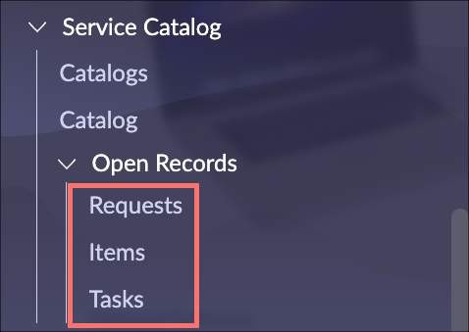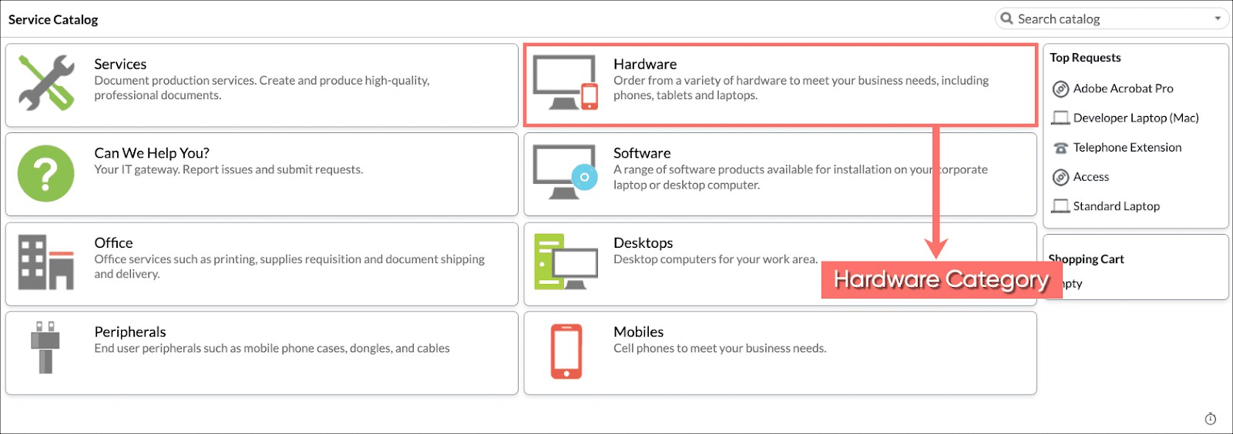

-----------------------------------------------------------------END--------------------------------------------------------------------------